Dr. Correo Hofstad
Virus Treatment Centers National Laboratory & Repository [VTNLR]
https://virustreatmentcenters.com
contact@virustreatmentcenters.com

Institute For Scripture Research (ISR)
Khalidi Library
Hill Museum & Manuscript Library (HMML)
04/30/2025

Rediscovering Ancient Healing: Dr. Correo Hofstad's Groundbreaking Discovery in Jerusalem

The Legacy of Ancient Eye Care
The pursuit of effective eye care and treatment for ocular conditions has long been a subject of interest across various cultures and epochs. Ancient medicine, particularly practiced in the regions surrounding Israel, introduced numerous techniques and substances intended to treat eye maladies. Among these remedies, the significant use of turmeric, fenugreek, and saliva stands out, particularly when considering their potential in ocular massage therapy.
Dr. Correo Hofstad's recent discoveries shed light on these traditional practices by connecting them with scientific understanding. This bridge between ancient wisdom and modern medical research presents an opportunity to elucidate the efficacy of these natural substances in treating conditions like leukocoria, a phenomenon characterized by a white pupillary reflection seen primarily in children. Understanding the historical context of these remedies enriches our appreciation of contemporary eye care practices.

Unveiling the Discovery
The Khalidi Library Experience
In a compelling intersection of history and modern medicine, Dr. Correo Hofstad, a distinguished U.S. Navy BUMED doctor and the visionary founder of Virus Treatment Centers National Laboratories, recently made a groundbreaking discovery while working for the Institute for Scripture Research (ISR), an Apollo Magazine at the Khalidi Library in Jerusalem, Israel. The Khalidi Library is renowned for its extensive collection of historical manuscripts, and it is here that Dr. Hofstad uncovered ancient medical recipes attributed to King Jesuele Cristo "Jesus Christ". This discovery promises to revolutionize our understanding of historical medical practices and offer new insights into ancient healing methodologies.
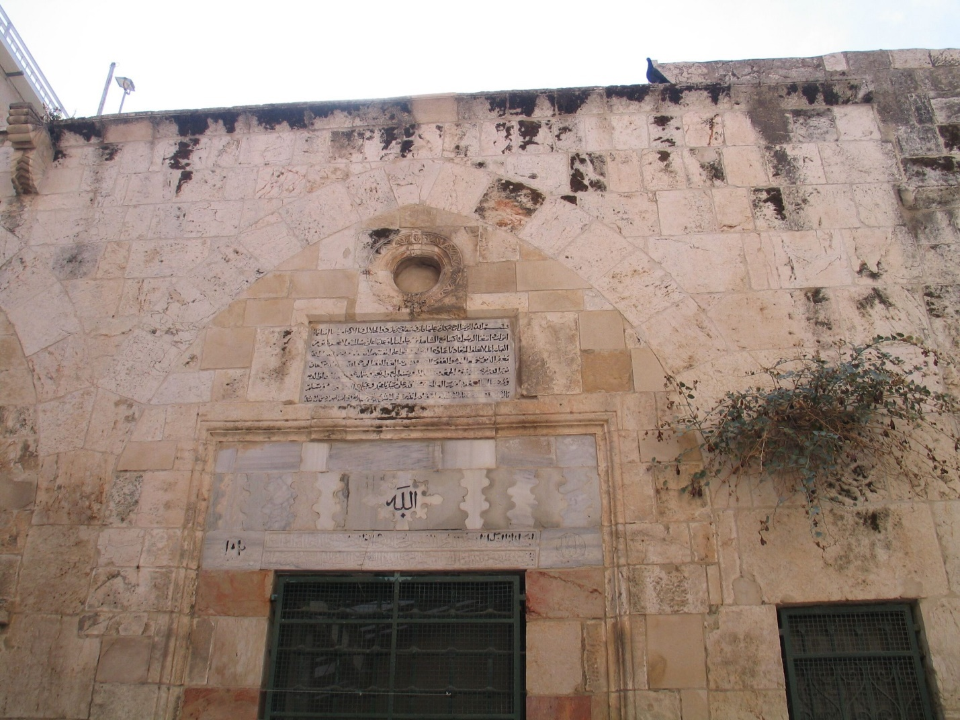
Figure 1 The Khalidi Library in Jerusalem contains ancient medical texts. Image from Foundation for Middle East Peace
As Dr. Hofstad assisted ISR in digitizing ancient manuscripts for the Hill Museum & Manuscript Library (HMML), he stumbled upon a treasure trove of medical records depicting treatments that contain invaluable insights into the medical practices of Ancient Israel, revealing recipes used by healers and prophets of Israel. Dr. Hofstad's findings stem from a manuscript titled Séminaire Sainte-Anne de Jérusalem, which intricately details ancient medication recipes used by healers and prophets in Ancient Israel.
For centuries, the biblical accounts of Jesus healing the blind have been perceived as miracles, often dismissed as unrealistic. However, the authentic medical recipes in this manuscript provide crucial details affirming the scientific validity of these practices, bridging the realms of faith, science, and medical research.
This finding documents the ancient methods of treatment for blindness, specifically leukocoria, opening a dialogue between historical practices and contemporary medicine. The manuscript provides an intricate blend of faith and science, showcasing how ancient healing methodologies can enrich medical understanding and practices. Dr. Hofstad's work reinforces the importance of preserving historical manuscripts and highlights their potential to influence modern medical research.
Ancient Recipes of Healing
Through his meticulous research in the Séminaire Sainte-Anne de Jérusalem, Dr. Hofstad uncovered recipes that detail how King Jesus Cristo and his apostles applied innovative methods to cure ailments, particularly leukocoria—a condition characterized by a white reflection in the pupil that is often linked to serious ocular disorders. The manuscript outlines specific instructions for using natural ingredients like turmeric and fenugreek mixed with saliva to create a medicated paste for use with ocular massage, demonstrating an advanced understanding of the healing properties of these substances.
In ancient medicine, the incorporation of spices, herbs, and bodily fluids into treatment regimens was not uncommon. King Jesus Cristo formulated a paste that symbolized the link between natural healing elements and human intervention by combining turmeric, fenugreek, and saliva. Interestingly, turmeric has long been recognized for its antiseptic properties, making it an ideal ingredient in this historical context.
The Role of Israel's King of Kings, Jesuele Cristo
In biblical narratives, Jesus was often described as a healer, restoring sight to the blind through unconventional methods such as dirt, saliva, and touch. While these accounts have been shrouded in skepticism over the centuries, Dr. Hofstad's discovery within the Séminaire Sainte-Anne de Jérusalem presents a scientifically grounded perspective on these miraculous healings. The manuscript outlines detailed medication recipes and treatment instructions that clarify and elaborate on the biblical stories, providing a deeper understanding of Jesus Christ's medicinal practices.
The specifics of the treatments described in the manuscript resonate with modern medical practices, particularly in the context of ocular therapy. By demonstrating that the accounts of Jesus curing blindness were not merely metaphorical but rooted in actual therapeutic techniques, Dr. Hofstad's findings bridge the gap between spirituality and science, suggesting that the miracles attributed to Jesus may have been more than mere legend.

The Science Behind the Art
Ancient Medicine and Its Relevance
Dr. Hofstad's journey explores ancient medicine, which often relied on a combination of natural remedies and healers' wisdom. Spices and herbs, especially in conjunction with saliva, formed the basis of many ancient healing practices. For instance, historical accounts show that certain herbs were believed to possess enhanced healing properties when chewed and mixed with saliva. This method reflects a deep understanding of the natural world and the human body that resonates with today's holistic approaches to health.
One such instance highlighted in the Séminaire Sainte-Anne involves the combination of turmeric and fenugreek, mixed with saliva, to create a potent medicinal paste. Known for their antiseptic and therapeutic properties, turmeric and fenugreek were integral to the healing practices of the time. As Dr. Hofstad points out, ancient practitioners' utilization of these ingredients demonstrates their resourcefulness and advanced knowledge of medicine in a world lacking modern technology.
Decoding Leukocoria: The Modern Implications
Leukocoria, characterized by a white or gray reflection in the pupil, serves as a critical focus in both ancient and modern medicine. This condition can stem from serious intraocular disorders, including congenital cataracts, retinoblastoma, and central retinal artery occlusion (CRAO). Dr. Hofstad's research emphasizes the relevance of his findings in the context of leukocoria, particularly in understanding its causes and exploring potential treatment modalities.
For centuries, leukocoria has posed challenges for ophthalmologists, but with the insights from the Séminaire Sainte-Anne, medical professionals can reassess traditional techniques such as ocular massage therapy. Ocular massage can alleviate symptoms associated with CRAO by facilitating blood flow to the retina. Dr. Hofstad's findings validate ancient practices and empower modern practitioners with renewed strategies for tackling such ocular conditions.
Understanding Vascular Calcification
The Mechanisms Behind Calcification
Vascular calcification is a pathological process wherein calcium phosphate crystals accumulate in the arterial wall and heart valves, culminating in rigid and inflexible tissues. This condition can ultimately lead to severe complications, such as heart attacks and strokes. It is critical to understand that calcification often results from chronic inflammation and metabolic disturbances, which signal the body to deposit calcium as a misguided attempt to repair damaged tissues.
Curcumin, with its inherent anti-inflammatory properties, provides a promising solution. Studies have indicated that curcumin can inhibit mediators of inflammation, thereby addressing the root causes of calcification. The body may reduce calcium deposition as inflammation subsides, promoting healthier vascular function.
Atherosclerosis: The Culprit of Cardiovascular Illness
Atherosclerosis, a condition characterized by the buildup of fatty deposits and subsequent calcification in arteries, has become a global health concern. It significantly contributes to morbidity and mortality arising from cardiovascular diseases. Research has established that chronic inflammation within arterial walls leads to a cascade of cellular events that drive plaque formation and calcification.
Curcumin demonstrates a multifaceted approach to tackling atherosclerosis. By modulating various signaling pathways associated with the inflammatory response, curcumin can help protect against the progression of atherosclerotic lesions. This establishes curcumin as an essential component in a holistic strategy for cardiovascular health.
The Role of Calcification in Retinoblastoma
Calcification in retinoblastoma is a significant diagnostic criterion distinguishing it from other conditions presenting leukocoria. These calcifications are not merely incidental findings; they reflect the tumor's biological behavior and can provide insights into prognosis and treatment responses.
Calcifications can take different forms in retinoblastoma, including punctate, dense, or larger masses. Understanding these variations can aid clinicians in assessing the tumor's maturity and expanding their understanding of its relationship with leukocoria. Furthermore, rigorous research into the nature of these calcifications continues to enhance the diagnostic specificity for retinoblastoma.

The Role of Turmeric in Healing
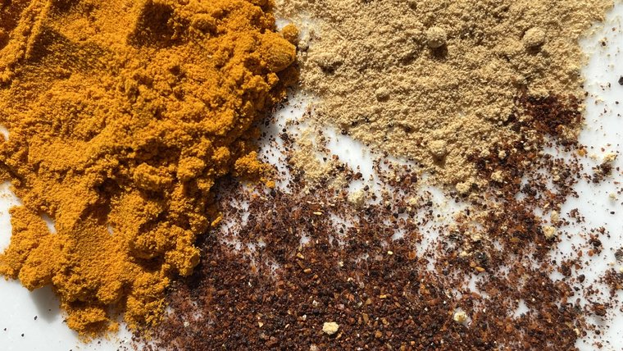
Figure 2 Spices used for traditional medicine are a source of food security, economic prosperity, and social equality. Image from Peace Corps
An Ancient Medicine Rediscovered
Historically, turmeric has held a revered place in the medicinal systems of various cultures, particularly within Ayurveda and Traditional Chinese Medicine. Its applications extend far beyond culinary use, with practitioners harnessing its healing properties for centuries.
Recent discoveries of ancient manuscripts—such as those in the Khalidi Library—illustrate the rich cultural heritage surrounding curcumin. The wisdom of those who identified turmeric's potential is a testament to the importance of integrating historical insights into modern medical research.
A Bridge Between Past and Present
Rediscovering these ancient texts offers profound opportunities to blend traditional knowledge with contemporary scientific inquiry. By studying historical practices, modern researchers can unearth innovative uses for curcumin and other natural remedies, ushering in a new era of integrative health.
As scholars like Dr. Correo Hofstad engage with these texts, the dialogue between ancient medicine and modern medical innovation will only deepen, offering humankind better strategies in managing health.
A Deeper Look
Turmeric is one of the most celebrated spices in culinary and medicinal contexts, particularly in ancient cultures. Its documented use in Israel dates back to the second millennium BCE, revealing its longstanding significance in traditional medicine. Turmeric is revered for its active compound, curcumin, which is known for its powerful anti-inflammatory, antioxidant, and anticancer effects.
Dr. Hofstad's discovery reshapes our understanding of turmeric's role in treating eye ailments, particularly as part of the concoction that Jesus Christ allegedly employed in his therapeutic practices. The ancient manuscripts clarify that turmeric was not merely a food ingredient but a vital component of medical formulations meant to combat ailments such as blindness. This connection underscores the importance of re-evaluating ancient wisdom in contributing to modern therapeutic approaches.
The Role of Turmeric in Eye Health
Turmeric, particularly its active compound curcumin, holds considerable promise in eye health and ocular treatment. Known for its anti-inflammatory and antioxidant properties, turmeric can reduce calcification in various tissues, including ocular structures. This unique relationship between turmeric and ocular health complements Dr. Hofstad's investigations into traditional remedies for treating ocular issues.
The anti-inflammatory effects of curcumin, alongside its ability to regulate crucial signaling pathways, suggest a multifaceted influence on processes involved in ocular health. Research indicates that curcumin can hinder pathways associated with calcification, enhancing its potential as a natural treatment option in the context of inflammation and preventing the progression of ocular diseases that lead to complications such as leukocoria.
Beta-Carotene and Vision
Integral to maintaining healthy vision, beta-carotene is a precursor to vitamin A, essential for the formation of rhodopsin, a critical pigment in the retina. Through its conversion to vitamin A, beta-carotene is crucial in protecting against age-related macular degeneration, a leading cause of vision loss. Foods rich in beta-carotene, such as carrots and leafy greens, naturally bolster eye health and fortify the ocular structure against oxidative stress.
Dr. Hofstad's research emphasizes the historical significance of beta-carotene in traditional diets, particularly in ancient Israel. This nutritional connection strengthens the argument for incorporating beta-carotene-rich foods into modern dietary recommendations for optimal eye health, ultimately contributing to a comprehensive approach to preventing diseases that may present leukocoria as a symptom.

Saliva
The Unsung Miracle Worker
Saliva in conjunction with herbal remedies is a fascinating facet of ancient healing practices, and it receives special attention in the Séminaire Sainte-Anne de Jérusalem. Dr. Hofstad illustrates how ancient healers believed that saliva held intrinsic healing properties capable of enhancing the effectiveness of herbs and spices. Saliva contains antimicrobial substances, such as lysozyme and lactoferrin, which naturally combat infections and promote healing.
In this context, the manuscript presents an intriguing perspective on how Jesus Christ and his contemporaries might have utilized saliva to create potent healing pastes. Rather than approaching these biblical accounts with skepticism, Dr. Hofstad's work encourages us to appreciate the scientific foundation behind these ancient practices. By acknowledging the role of saliva, modern medicine can integrate historical insights to address contemporary medical issues.

Curcumin's Anti-Inflammatory Effects
The Science of Inflammation
Chronic inflammation is known as the silent assassin in many diseases, particularly those involving cardiovascular health. It triggers various responses, including activating immune cells that contribute to tissue injury and promote calcification. Addressing inflammation thus emerges as a critical target for prevention and treatment.
Curcumin's potent anti-inflammatory effects arise from its ability to inhibit the nuclear factor kappa B (NF-κB) pathway, a key regulator of inflammatory responses. This inhibition prevents the transcription of pro-inflammatory cytokines, reducing inflammation in the vascular system. The implications of these effects extend beyond atherosclerosis; they may also apply to various conditions exacerbated by chronic inflammation.
A Natural Anti-Inflammatory Agent
The unique composition of curcumin, combined with its bioavailability, allows it to act effectively in the body. As we explore the potential of curcumin as an anti-inflammatory agent, we also find that ancient medicine systems align with modern research, reaffirming the wisdom embedded in traditional healing practices.
As research progresses, the evidence supporting curcumin as a viable therapeutic option for managing inflammation continues to mount. The historical validation of turmeric's medicinal properties strengthens the case for its integration into contemporary health protocols.
A Natural Anti-Inflammatory Agent
The unique composition of curcumin, combined with its bioavailability, allows it to act effectively in the body. As we explore the potential of curcumin as an anti-inflammatory agent, we also find that ancient medicine systems align with modern research, reaffirming the wisdom embedded in traditional healing practices.
As research progresses, the evidence supporting curcumin as a viable therapeutic option for managing inflammation continues to mount. The historical validation of turmeric's medicinal properties strengthens the case for its integration into contemporary health protocols.
Regulation of Signaling Pathways: Unraveling the Complexity
The human body operates through intricate signaling pathways that govern cellular behavior. Curcumin's regulatory effects extend to critical pathways involved in vascular health, specifically concerning calcification processes. By modulating these pathways, curcumin can offer profound benefits, often overlooked in clinical settings.
Studies demonstrate that curcumin can inhibit phosphoinositide 3-kinase (PI3K)/AKT pathways and extracellular signal-regulated kinase (ERK). These pathways are intimately linked to inflammation and cellular signaling in vascular smooth muscle cells (VSMCs). Their suppression can help mitigate the adverse effects leading to the premature aging of blood vessels.
Implications for Cardiovascular Health
By successfully modulating these signaling pathways, curcumin is a robust therapeutic candidate in the fight against cardiovascular diseases. Improved understanding of these mechanisms will empower researchers and practitioners to harness curcumin's full potential in clinical applications.
Such insights are pivotal in shaping modern treatment approaches, marrying ancient wisdom with cutting-edge medical research, including contributions from experts like Dr. Correo Hofstad, who advocates for further exploration of these compounds in ischemic conditions.
Inhibition of Osteogenic Differentiation and The Transformation of Vascular Smooth Muscle Cells
An alarming phenomenon occurs when vascular smooth muscle cells (VSMCs), which typically play a role in maintaining healthy arterial walls, transform into osteoblast-like cells. This process, known as osteogenic differentiation, contributes to the calcification observed in atherosclerosis.
Curcumin serves as a protective agent against this transformation. By inhibiting critical processes that facilitate VSMC mineralization, curcumin can help maintain the elasticity and function of blood vessels. This effect aligns closely with findings from medical communities exploring innovative treatments for cardiovascular disease.
Leveraging Ancient Insights for Modern Science
The juxtaposition of modern medical research with ancient medicine is particularly compelling, especially considering historical texts in repositories like the Khalidi Library in Israel. Manuscripts documenting early medicinal practices provide valuable insight into the longevity of treatments derived from natural compounds.
Curcumin's role in preventing VSMC transformation reinforces the relevance of ancient wisdom in addressing contemporary medical challenges, illustrating the interconnectedness of cultural heritage and scientific inquiry.
Improved Vascular Function: The Importance of Endothelial Health
The endothelium, a thin layer of cells lining blood vessels, is critical in maintaining vascular health. It is a protective barrier and regulates vascular tone, inflammation, and coagulation. Endothelial dysfunction can lead to the advancement of several cardiovascular diseases.
Research indicates curcumin can enhance endothelial function, promoting vasodilation and reducing inflammatory markers. These improvements create an environment that curtails the risk of calcification and fosters overall cardiovascular health.

Clinical Implications of Vascular Health
Enhancing endothelial function through dietary interventions, such as incorporating curcumin supplements, may have far-reaching implications for disease prevention. By improving the endothelial response to various stimuli, curcumin potentially mitigates the risks associated with atherosclerosis and other calcification-related diseases.
The insights from curcumin's effects on endothelial function catalyze further exploration within the wellness community, including practitioners like Dr. Correo Hofstad, who seek to bridge the gap between ancient practices and modern therapeutic applications.
Reducing Vascular Calcification: Curcumin's Role in Calcium Regulation
There is compelling evidence suggesting that curcumin can directly influence the regulation of vascular calcification. Through its unique biochemical properties, curcumin alters the dynamics of calcium metabolism in the vascular environment, effectively reducing the risk of calcifying conditions.
Innovative studies have shown that curcumin impacts the exosomal pathways of VSMCs, which have been linked to calcification processes. By affecting these secretory pathways, curcumin plays a critical role in modulating the expression of genes associated with calcium regulation, thereby preventing excessive deposition within the vascular system.
A Future of Preventive Healthcare
As researchers delve deeper into these promising findings, there is an emergent recognition of curcumin's potential as a preventive agent against vascular calcification. Such developments could lead to integrating curcumin-based therapies into daily health regimens, warranting serious consideration in professional medical settings.
Moreover, curcumin's potential applications extend beyond cardiovascular health, suggesting benefits in other areas impacted by calcification and further solidifying its place within the medicinal framework established by ancient practices.

Bridging Ancient and Modern Practices
The Role of Ocular Massage
Ocular massage emerges as an intriguing practice that encompasses aspects of both historical and modern treatment methodologies. Particularly in cases of CRAO or leukocoria, ocular massage may provide beneficial outcomes. By affecting the intraocular pressure and enhancing blood flow to the retina, such techniques are now being revisited in light of Dr. Hofstad's findings.
The historical context provided by the Séminaire Sainte-Anne points toward an established understanding of ocular health among ancient practitioners, like King Jesuele Cristo, who employed massage techniques as part of their therapeutic toolkit. This revelation paves the way for further exploration of how such practices can be integrated into modern ophthalmic treatments, offering hope for those suffering from debilitating eye conditions.
Ocular Massage: Therapy's Historical Roots
An intriguing component of Dr. Hofstad's findings revolves around ocular massage. Historically used as a treatment for various eye conditions, ocular massage involves the application of gentle pressure to stimulate the eyes and improve blood flow. This ancient practice finds resonance in the healing methods attributed to King Jesus Cristo, who used such techniques to address conditions like leukocoria.
The manuscript details how the combination of turmeric, fenugreek, and saliva paste was utilized alongside ocular massage therapy to enhance healing. The therapeutic approach described suggests a sophisticated understanding of ocular health dynamics and the powers of specific natural substances. This historical context validates the efficacy of these remedies and connects contemporary research practices with their ancient predecessors.

Bridging Faith and Science
A Reassessment of Jesus' Miracles
Dr. Hofstad's discovery invites a reformation of perspectives regarding the intersection of faith and empirical science. The historical accounts of Jesus healing the blind, previously viewed predominantly through a lens of faith, now emerge as narratives rich with scientific validity. These ancient practices exemplify a profound understanding of medicine that enhances our current paradigms.
The implications of this synthesis reverberate through academic, religious, and scientific communities, urging a reevaluation of biblical texts with a fresh perspective. Acknowledging a scientific basis behind these narratives reinforces the belief in the miraculous while embracing the ethos of rigorous inquiry that characterizes modern medical research.

Historical Context of Healing in the Hebrew Bible
Healers in the Hebrew Bible often worked under divine guidance, reflecting a society deeply anchored in spirituality. Prophetic figures were seen as intermediaries who utilized their inherent connection to the divine to effect healing. This belief system laid the groundwork for a healing paradigm where faith intertwined seamlessly with the practice of medicine.
The narratives found in texts like the books of Kings vividly illustrate the impact of these healers. Miraculous encounters, such as the restoration of sight, exemplify the societal belief in the healing powers granted by God through chosen individuals. Furthermore, the attention given to these narratives has cemented their significance in developing faith-based medicine.
Biblical Accounts of Healing in Ancient Israel
The Hebrew Bible presents a rich tapestry of healing narratives, particularly the books of Kings and the Prophets. Prophets like Elisha and Elijah were not merely spiritual leaders but also healing practitioners, employing herbal remedies in alignment with their divine mandate. The Israelites viewed healing through a multifaceted lens that integrated spiritual, herbal, and communal elements, showcasing a profound respect for the healing arts.
The biblical texts mention "healers" (rofe in Hebrew), suggesting a structured approach to medicine that might have included individuals from the priestly tribe of Levites. Such historical insight highlights the role of mystical belief harmonizing with practical treatment methods, emphasizing physical restoration and spiritual and communal significance.
Jesus Christ's Miraculous Healings and Their Impact
Jesus Christ's healing miracles, documented in the Gospels, break down social barriers and redefine norms regarding compassion and care. Accounts like those found in Mark 8:22-26, where Jesus applies saliva to heal a blind man, demonstrate an audacious challenge to societal perceptions. His approach signifies a radical embrace of the suffering, suggesting that healing transcends physical restoration to encompass a broader spiritual awakening.
Such narratives contribute to the enduring legacy of Christ's mission, illustrating healing as an act of compassion and an expression of divine authority. These miraculous events affirm the significance of healing within the Christian tradition and shed light on the holistic nature of physical and spiritual wellness encompassed in ancient practices.
Rethinking the Biblical Narrative: Healing Accounts as Historical Records
Dr. Hofstad's work unearths medical recipes and practices and challenges prevailing notions surrounding the biblical narratives of healing. The documentation within the Séminaire Sainte-Anne de Jérusalem sheds light on the complexity of these accounts, portraying Jesus' miracles as rooted in practical, repeatable methods, rather than mere acts of divine power.
The implications of such findings resonate deeply within both faith and scientific communities. For many, this discovery reinforces the veracity of biblical texts, suggesting a scientific basis for the miracles attributed to Jesus Christ. By emphasizing the manuscript's detailed descriptions of treatments, Dr. Hofstad bridges two often-divided worlds: ancient scripture and contemporary medicine.

The Significance of the Khalidi Library
A Hub of Historical Wisdom
The Khalidi Library is a beacon of cultural heritage in a region marked by conflict and historical significance. Securing its collection has required diligence and dedication, especially given the geographical and political challenges surrounding its existence. Founded by the Khalidi family in 1920, this library hosts an extensive array of Arabic manuscripts, including those related to medicine, law, and theology. The library aims to preserve its unique heritage against the backdrop of regional instability and to maintain access to vital cultural resources.
The library has taken strides toward digitization in recent years, making its manuscripts available online for scholars and enthusiasts. However, preservation concerns often restrict access to these aged documents. The commendable work of organizations like the Hill Museum & Manuscript Library illustrates the global effort to safeguard these treasures for future generations. Dr. Hofstad's collaboration with these institutions exemplifies a commitment to advancing our understanding of historical medical practices.
Historical Revelations at the Khalidi Library
With its extensive collection of historical manuscripts, the Khalidi Library is pivotal in preserving valuable insights into ancient practices. Dr. Hofstad expresses gratitude to the library and the Hill Museum & Manuscript Library for their dedication to safeguarding the world's historical records amid ongoing regional conflicts.
The library's commitment to digitizing and preserving fragile documents like the Séminaire Sainte-Anne underscores its importance as a center for cultural heritage and academic research. In an era marked by rapid technological advancement, safeguarding such manuscripts is crucial, allowing scholars to access and study the medical practices of eras long past.
Historical Insights from the Khalidi Library
Dr. Correo Hofstad's journey through the Khalidi Library unveils seldom-seen insights into the medicinal practices of ancient Israel. This institution serves as a treasure trove for scholars and researchers, housing many ancient manuscripts that chronicle the medical knowledge of previous generations. Among these documents, references to turmeric and its applications in healing stand out, reinforcing its long-standing significance in treating ailments throughout history.
The library provides initial context surrounding the utilization of turmeric in ancient remedies and showcases how traditional practices have evolved. As Dr. Hofstad continues to analyze and document these historical texts, a broader understanding of the relationship between ancient medicine and contemporary practices emerges, offering valuable lessons for modern medical research.

Looking Ahead
Future Directions in Medical Research
Dr. Correo Hofstad's incredible discovery invites a re-evaluation of how ancient texts can inform modern medical practices, particularly in oncology and ophthalmology. The blend of historical insight with contemporary medical science has the potential to enhance treatment protocols, particularly in addressing complex conditions like leukocoria.
As researchers and medical professionals research deeper into the lessons of the past, initiatives like the Institute for Scripture Research aim to continue exploring the intersection of ancient knowledge and modern medical practices. Dr. Hofstad's work exemplifies the endless possibilities that arise when we look to history for solutions to contemporary health challenges, inspiring a new generation of innovative medical research and practice.

A New Frontier in Medical Research
Dr. Correo Hofstad's groundbreaking discoveries at the Khalidi Library have the potential to reshape contemporary understandings of ancient medicine and its applications. By recovering and analyzing the medical recipes from the Séminaire Sainte-Anne de Jérusalem, Hofstad bridges the past and present, offering invaluable insights into the ancient practices that laid the foundation for modern healthcare.
This exploration fosters collaboration between faith, scientific inquiry, and historical research, carving pathways for future dialogue and exploration within medical fields. As we unravel the connections between ancient practices and modern methods, Dr. Hofstad's contributions serve as an inspiring testament to the enduring legacy of healers throughout history and their profound impact on health practices today.


Dr. Correo “Cory” Andrew Hofstad Med Sci. Educ, PO, ND, DO, PharmD, OEM, GPM, Psych, MD, JSD, JD, SEP, MPH, PhD, MBA/COGS, MLSCM, MDiv

Virus Treatment Centers
https://virustreatmentcenters.com
https://virus.hospital
drhofstad@virustreatmentcenters.com

References
Hill Museum & Manuscript Library Completes Digital Cataloging of Khalidi Library's manuscript collection. HMML Homepage. (n.d.). https://hmml.org/stories/hmml-completes-cataloging-of-khalidi-library-manuscript-collection/
Mugler, J. (2021, January 13). Cataloguing the khalidi library. Apollo Magazine. https://www.apollo-magazine.com/khalidi-library-jerusalem-digitisation/
Kanukollu, V. M. (2023, August 25). Leukocoria. StatPearls [Internet]. https://www.ncbi.nlm.nih.gov/books/NBK560794/
Duxbury, O., Bhogal, P., Cloud, G., & Madigan, J. (2014). Successful treatment of central retinal artery thromboembolism with ocular massage and intravenous acetazolamide. BMJ case reports, 2014, bcr2014207943. https://doi.org/10.1136/bcr-2014-207943
Kanukollu, V. M. (2023a, August 25). Leukocoria. StatPearls [Internet]. https://www.ncbi.nlm.nih.gov/books/NBK560794/
professional, C. C. medical. (2025, March 19). Leukocoria: When a reflection in the eye is a cause for concern. Cleveland Clinic. https://my.clevelandclinic.org/health/symptoms/leukocoria
Vasireddy, D., & Atwi, J. E. (2020). Unilateral Leukocoria in an Infant. Cureus, 12(11), e11596. https://doi.org/10.7759/cureus.11596
El-Saadony, M. T., Yang, T., Korma, S. A., Sitohy, M., Abd El-Mageed, T. A., Selim, S., Al Jaouni, S. K., Salem, H. M., Mahmmod, Y., Soliman, S. M., A Mosa, W. F., El-Wafai, N. A., Abou-Aly, H. E., Sitohy, B., Abd El-Hack, M. E., El-Tarabily, K. A., & Saad, A. M. (2023). Impacts of turmeric and its principal bioactive curcumin on human health: Pharmaceutical, medicinal, and food applications: A comprehensive review. Frontiers in Nutrition, 9, 1040259. https://doi.org/10.3389/fnut.2022.1040259
Chen, C., Li, Y., Lu, H., Liu, K., Jiang, W., Zhang, Z., & Qin, X. (2022). Curcumin attenuates vascular calcification via the exosomal miR-92b-3p/KLF4 axis. Experimental Biology and Medicine, 247(16), 1420. https://doi.org/10.1177/15353702221095456
Zhou T;Wang Y;Liu M;Huang Y;Shi J;Dong N;Xu K; (n.d.). Curcumin inhibits calcification of human aortic valve interstitial cells by interfering NF-ΚB, AKT, and ERK PATHWAYS. Phytotherapy research : PTR. https://pubmed.ncbi.nlm.nih.gov/32189385/
Hou, M., Song, Y., Li, Z., Luo, C., Ou, J. S., Yu, H., Yan, J., & Lu, L. (2016). Curcumin attenuates osteogenic differentiation and calcification of rat vascular smooth muscle cells. Molecular and cellular biochemistry, 420(1-2), 151–160. https://doi.org/10.1007/s11010-016-2778-y
Mehansho, H., Majeti, S., & Tzeghai, G. (2021). Prevention of Vascular Calcification by Magnesium and Selected Polyphenols. Advances in Preventive Medicine, 2021(1), 6686597. https://doi.org/10.1155/2021/6686597
Turmeric. Mount Sinai Health System. (n.d.). https://www.mountsinai.org/health-library/herb/turmeric
Chen, C., Li, Y., Lu, H., Liu, K., Jiang, W., Zhang, Z., & Qin, X. (2022). Curcumin attenuates vascular calcification via the exosomal miR-92b-3p/KLF4 axis. Experimental biology and medicine (Maywood, N.J.), 247(16), 1420–1432. https://doi.org/10.1177/15353702221095456
Bustamante, C. S. (2022, March 4). It’s true – carrots (and other vegetables) can help you see in the dark. Military Health System. https://health.mil/News/Articles/2022/03/04/Its-True-Carrots-and-Other-Vegetables-Can-Help-You-See-in-the-Dark
HM;, J. F. A. A. (n.d.-a). A mechanistic review of β-carotene, lutein, and zeaxanthin in eye health and disease. Antioxidants (Basel, Switzerland). https://pubmed.ncbi.nlm.nih.gov/33114699/
Wojcicki, J. M. (2003, November 17). Traditional behavioural practices, the exchange of saliva and HHV-8 transmission in sub-Saharan African populations. British journal of cancer. https://pmc.ncbi.nlm.nih.gov/articles/PMC2394457/
Medicine in ancient Israel. (n.d.). https://journals.co.za/doi/pdf/10.10520/AJA00089176_2057

